Goals:
- Every 5 seconds ONLY one of the following occurs (assume gap between cars) - Simulation - Poisson Distribution (play with the numbers so it makes sense)
Research how to work with LED
  - Car enters correct parking - #1 Green
  - Car enters wrong parking - #2 Red
  - Car exits correct parking - #3 Green
  - Car exits wrong parking - #4 Blue
- Cloud Statistics - Work with Firebase (RTDB) and ESP
  - Aggregation + Time stamp
    - Input (state, timestamp) -> Cloud
    - Output <- how many times state #1 occurred in what time
- GUI - Show Analysis of Cars Input: Cloud -> Output: Graphs, Pie chart
Python application that reads from Firebase // Simple Flutter application // …
  - Choose 3-4 kinds of analysis
    - Graph of accumulated states throughout the data
    - Pie chart - how many bad states (3-4) compared to (1-2)
    - Average number of …, Average time for car to leave…. Average parking time
    - When car arrives, what is the probability that it takes the correct location
    - Be creative!

Recommended Order of Operations:
- Design of the Cloud structure
- GUI from dummy data -> Start designing the statistics etc.
- When you acquire hardware
  - Work with LEDs
  - Read & Write to Firebase

Progress Updates
Day1 14 September
- FireBase:
  - Firebase Integration: Successfully configured Firebase project with Firestore real-time database
  - Flutter Application: Built cross-platform mobile app with Material Design.
  - Real-time Data Streaming: Implemented live data synchronization between cloud and mobile interface
- Four Event Types Implemented:
  - Event 1: Car enters correct parking → Green LED
  - Event 2: Car enters wrong parking → Red LED
  - Event 3: Car exits correct parking → Green LED
  - Event 4: Car exits wrong parking → Blue LED
- Mathematical Simulation:
  - Proper Poisson Distribution: Implemented Knuth's algorithm for realistic event generation
  - Configurable Lambda Parameters:
    - Correct Entry (λ=2.5): High frequency events
    - Wrong Entry (λ=0.3): Low frequency errors
    - Correct Exit (λ=1.8): Medium frequency events
    - Wrong Exit (λ=0.15): Very rare errors
  - 5-Second Interval Simulation: Automated event generation matching project requirements.
- Analytics Dashboard
  - LED Distribution Chart: Pie chart showing event type distribution
  - Average Wait Time Tracking: Novel analytics showing events between specific occurrences: The algorithm tracks how many events occur between each appearance of a specific event type. It maintains running counters and calculates averages over time.
  - Real-time Event Feed: Live display of recent parking events
  - Statistics Overview: Event counts and success rate calculations
- User Experience
  - Manual Simulation Control: Start/stop functionality via floating action button
  - Data Management: Clear all data feature with confirmation dialog
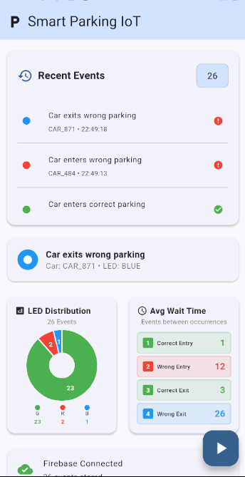

18 September
- Material Design Tabs Implementation:
  - Tab Structure: Split interface into two focused tabs: "Event Analytics" and "Car Tracking
  - UI Optimization: Resolved screen overcrowding by distributing content across tabs
- Car Tracking System:
  - Car Session Management: Tracks individual car parking sessions with entry/exit times
  - Active Cars Monitoring: Real-time display of currently parked vehicles with duration tracking
  - Session History: Maintains record of completed parking sessions with calculated durations
  - Statistics Cards: Three-card summary showing Cars in Parking, Average Minutes, and Completed sessions
- Simulation Realism Enhancement:
  - Smart Car ID Generation: Implemented realistic logic where exit events preferentially use existing parked cars.
  - Guaranteed Realistic Car Selection:
    - Always select random car from existing ones for exits
    - Convert exit events to entry events when parking is empty
  - Session Completion: Cars can now complete full entry→exit cycles, enabling meaningful duration calculations
  - wrongExit is a car that made a wrong enrty.?? Yes
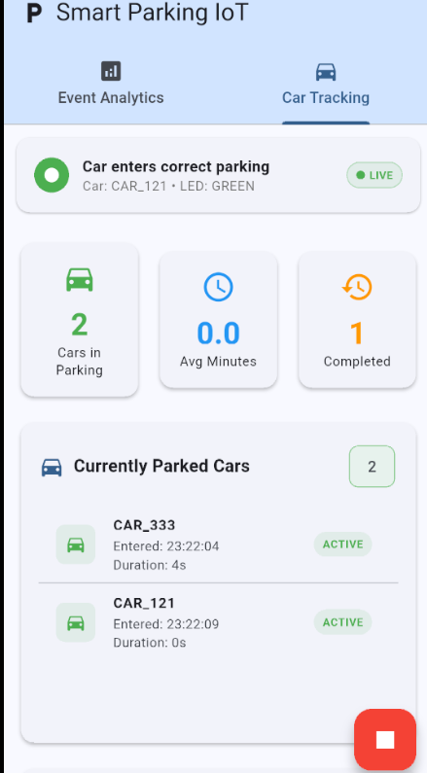

- Next
  - Hardware
  - Planning to add more analytic statics about probability, what happens in our simulation comparing to what we expect according to the probability theory.
  - Or maybe instead of theoretical stats, I may add live park..that show visual park

19 + 20 September
Major
- Learning new skills: following the workships guidance, I learned about:
  - Esp
  - Led, jumpers
  - tested the hardware, and wrote a program that runs the three colours serially using serial monitor to debug.
- Switch to RTDB(real time database) instead of cloud firestore
- In red = todo green- Almost Done
- Upload full ESP32 code (parking simulation)
- Connect: ESP32 → Firebase → Flutter
- Simulation Logic: same as previous one, but with C++ in ESP instead of flutter,
summary :ESP32 generates parking events every 5 seconds, sends to Firebase, Flutter shows real-time dashboard.
Almost Done with our first Goals!! Should fix some minor problems

least important

Flutter Changes Made:
  - Performance Optimization:
- Rebuilding relevant fields(boxes) instead of refreshing the whole page.
(Before: Entire screen rebuilds on every Firebase update After: Only specific sections rebuild when their data changes)
  - User Interface:
- (By instructor advice) Event Analytics Tab: Charts → Recent Events → Control Section
- Removed FAB simulation button and related animations
- Removed Firebase writing methods (commented for reference)
- Kept only Firebase reading functionality
- Added ESP32 connection status indicator
- Updated UI text to show "Waiting for ESP32 data..."
- sorting recent data: new cars at the top of the lists for instance: recent parking sessions.
- every 5 seconds the proper colour should be on the led, what if it is the same colour? then should blink
- Performance limits - Max 20 items processed in lists

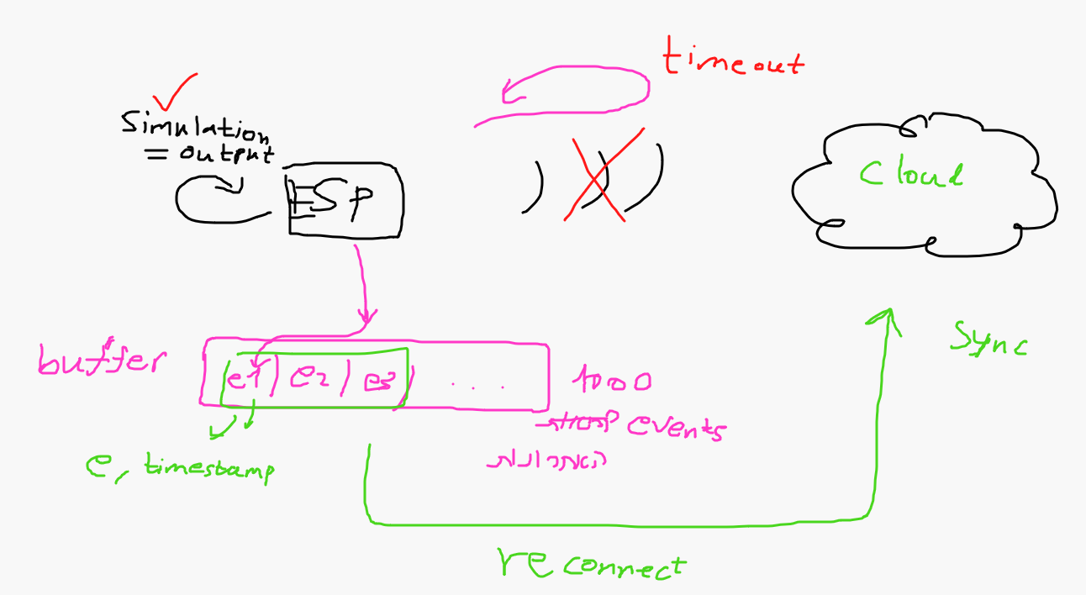

Vff

21 + 22 September
The two major changes:
- Using WiFiManager instead of hardcoding credentials. The ESP32 becomes a temporary WiFi hotspot where users can select and configure WiFi settings through a web interface.
- Handling an edge case where the network cuts off. Solved by saving the data temporarily to a buffer, and after getting back the network upload to firebase with proper timestamps!!
המטרות החדשות:
- זיהוי ניתוק רשת - הESP32 יזהה כשהאינטרנט נותק
- Buffer פנימי - ישמור עד 1000 אירועים כשאין אינטרנט
- סנכרון אוטומטי - כשהאינטרנט חוזר, ישלח את כל הBuffer ל-Firebase
- Timestamp נכון - ישמור את הזמן האמיתי של האירוע (לא זמן קבלה ב-Firebase)

Minor bugs:
- List now shows all events (not limited to 20)
- Fixed avg minutes in car tracking
- Update the average minutes calculation to also count ongoing parked cars.
- Make the list of recent parking sessions sorted by exit time (descending).
- Fixed minor bug in avg wait time..
New features!:
- New graph that shows number of parked cars related to time. It updates every 30 seconds ( 6 events): the chart shows the last 25 minutes of parking occupancy history
It has 50 individual measurements (one every 30 seconds)
- 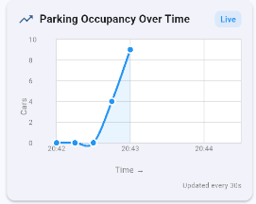
- 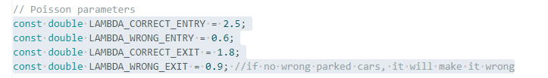
Updated to see more wrong entries and exits.

23 September goals:
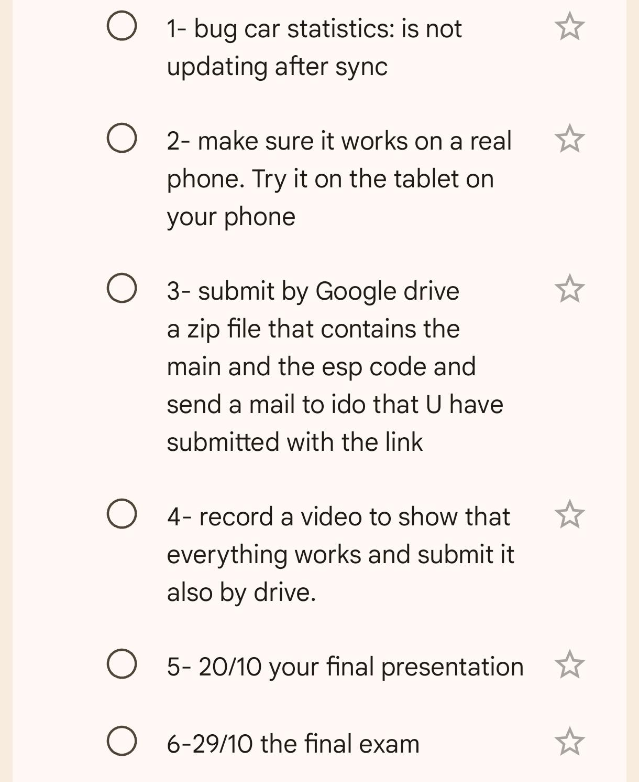

Smart Parking IoT System - Project Highlights

Core System Architecture
Complete IoT Pipeline: ESP32 → Firebase RTDB → Flutter Mobile App with real-time synchronization

Key Technical Achievements

Mathematical Simulation (Day 1)
- Proper Poisson Distribution using Knuth's algorithm
- Realistic Event Generation with configurable lambda parameters:
  - Correct Entry (λ=2.5) | Wrong Entry (λ=0.3)
  - Correct Exit (λ=1.8) | Wrong Exit (λ=0.15)
- 5-second interval automation matching project requirements

Advanced Car Tracking System (Day 4)
- Smart Car Session Management with entry/exit time tracking
- Realistic Simulation Logic: Exit events use existing parked cars only
- Guaranteed Session Completion: Full entry→exit cycles with duration calculations
- Active Cars Monitoring: Real-time display of currently parked vehicles

Mobile Analytics Dashboard
Material Design Implementation:
- Tabbed Interface: "Event Analytics" and "Car Tracking"
- Real-time Data Visualization: Pie charts, timeline graphs, event feeds
- Novel Analytics Algorithm: Tracks events between specific occurrences
- Performance Optimization: Selective rebuilding instead of full screen refresh

Hardware Integration (Day 6-7)
- ESP32 with LED System: Red/Green/Blue event indication
- WiFiManager Implementation: Web-based WiFi configuration
- Network Resilience: 1000-event buffer for offline operation
- Smart LED Control: Blinking for consecutive same-color events

Advanced Features (Day 8-9)
Network Fault Tolerance:
- Automatic network disconnection detection
- Internal buffer storing up to 1000 events during outages
- Auto-sync when connectivity restored with proper timestamps
Live Analytics:
- Parking Occupancy Graph: 25-minute history with 50 measurements
- Real-time Statistics: Average parking duration, success rates
- Session History: Complete parking records with calculated durations

Innovation Points
✅ Realistic Simulation: Prevents impossible scenarios (exits without entries)
✅ Network Resilience: Offline operation with automatic sync
✅ Smart Car Management: Session-based tracking with realistic behavior
✅ Performance Optimization: Selective UI updates for smooth operation
✅ Professional UX: Material Design with intuitive navigation

Technical Stack Mastery
- Embedded Programming: ESP32, WiFiManager, LED control
- Cloud Integration: Firebase RTDB with real-time synchronization
- Mobile Development: Flutter with Material Design
- Mathematical Modeling: Poisson distribution implementation
- System Architecture: Complete IoT pipeline design

Results Summary
Fully Functional System: Hardware simulation → Cloud storage → Mobile analytics with professional-grade features including network resilience, realistic car tracking, and comprehensive analytics dashboard.

